Regional Support Centre-North (RSC-N) was established in 2009 to provide drinking water supply facilities and advice to public & institutions, within Northern Province of Sri Lanka, under the headship of Deputy General Manager (DGM) with an Assistant General Manager (AGM). RSC-N is situated in Jaffna Road, Vavuniya. (Location Map & RSC-N map).
The O&M activities are divided into two regions namely “Jaffna Region” and “Vavuniya Region” and are managed by two separate Regional Managers (RM). The RSC-N covers entire Northern Province; RSC North consists 31 schemes; 29,849 number of connections as at June, 2020. NWSDB coverage of the North Region is 10.15% as at June 2020.
The RSC-N has a strength of 220 Employees. RSC-N consists a Laboratory testing facilities, for Water quality, accredited with ISO certificate, in each region. RMs report to DGM through AGM. The functions of RSC-North is monitored and advised by the Additional GM (North-Central) who is stationed in Head Office, Rathmalana.
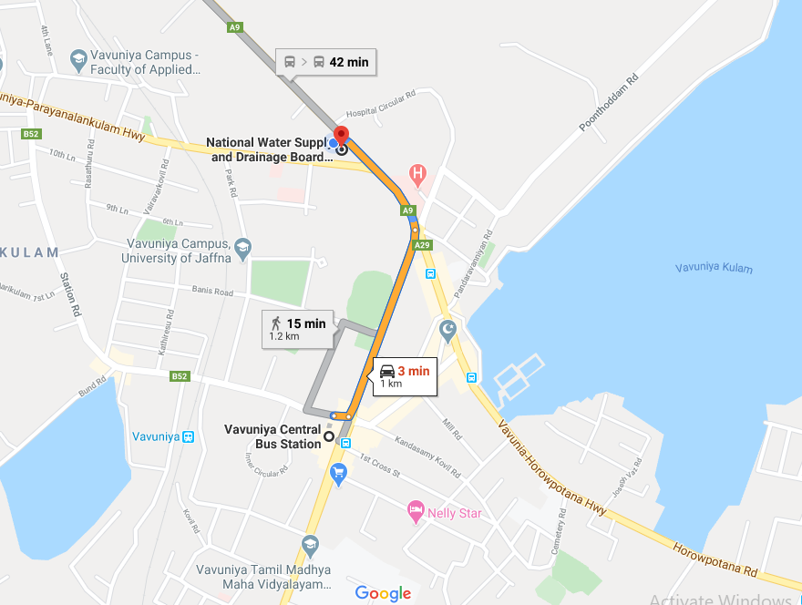

Location map of RSC North office
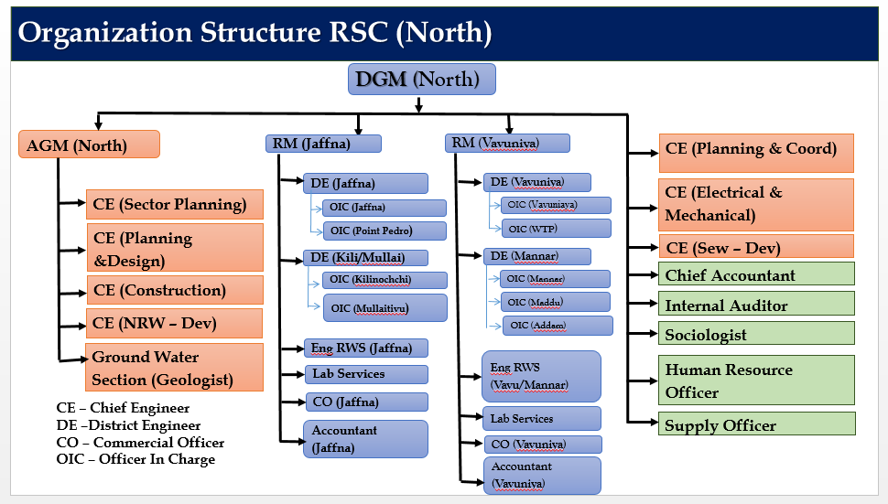

Organization Chart of RSC North office
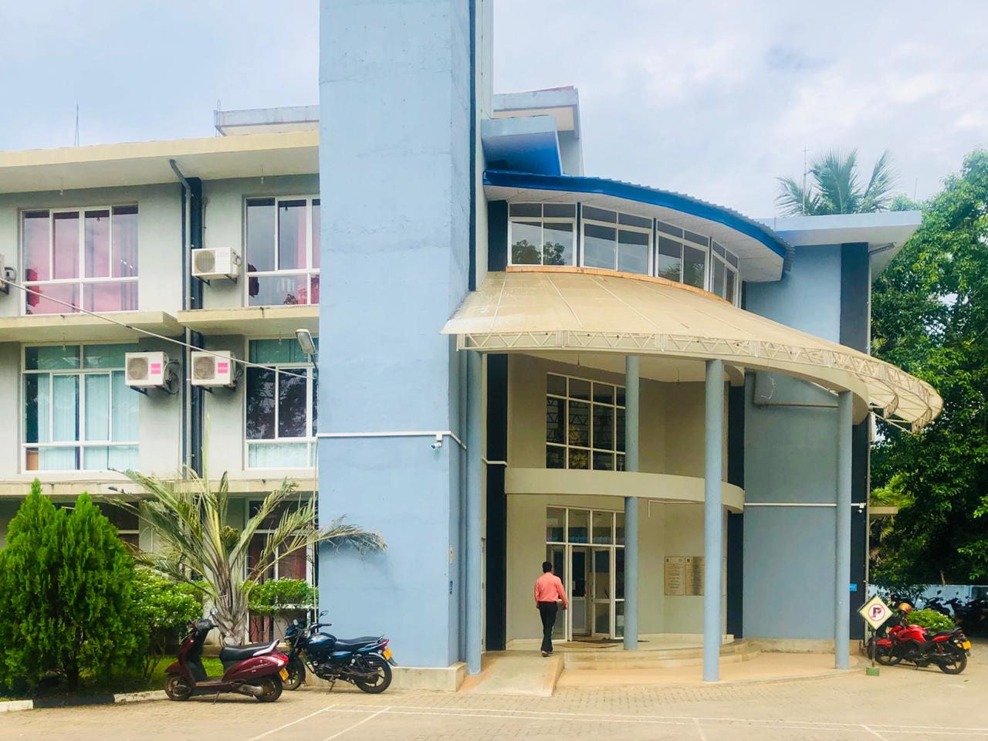

RSC North office

The principal functions of RSC-N are to provide necessary technical support to the two regional offices related to rehabilitation & augmentation work in existing scheme; non –technical assistance for smooth functioning, as well. Other key functions of RSC are:
- Sector Planning of drinking water supply for entire northern Region and identify major & minor projects
- Planning & Design of minor but urgent needed projects.
- Implementation of rehabilitation and augmentation works of existing schemes;
- Investigation of Deep wells for external institutions and private land owners.
- Procurement of goods and services
- Testing of Water quality parameters on public and institutions request.
- Billing & Revenue collection;
Budgetary control is decentralized and vested with DGM for efficient performance of RSC.
The Regional Laboratories of Jaffna & Vavuniya had met the Management Requirements and Technical Requirements of ISO 17025 and were granted ISO 17025 accreditation for 5 parameters of PH, Turbidity, Electrical Conductivity, Total hardness and Chloride and in progress of getting accreditation for microbiological testing.
IT Infrastructure and Solutions to suit the needs of the organization have been taken while keeping pace with the latest trends in the industry. Some of these activities include On-line Bill Payment facility, Smart Zone for 24-hour service facilities, On-line Customer Grievance Handling Applications, use of Mobile App for Meter Reading, Drive-thru Bill Payment facility etc.

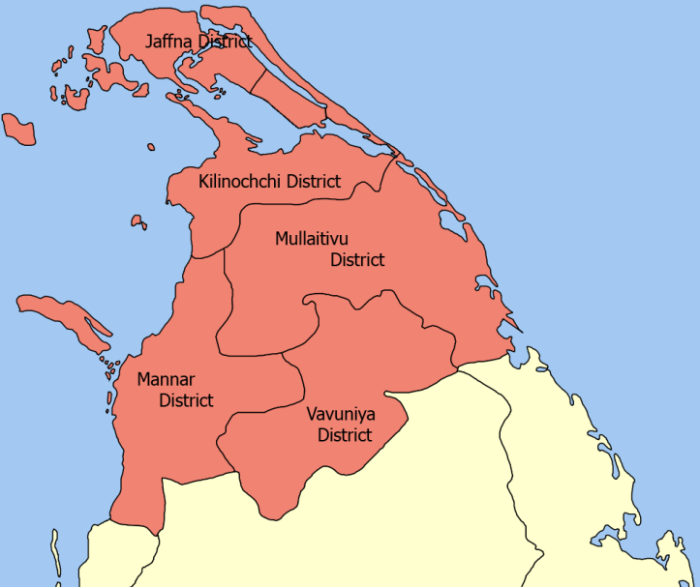

Northern province map

Profile of Northern Province
Districts | 5
Divisional Secretariats | 36
Total Extent (Sq.km) | 8,884.0
Population 2019 | 1,246,453
No.of Families | 388,594
Population Density (per/sq.km) | 140
Geographic profile | - Jaffna Peninsula; (2) Vanni
No.of Islands (inhibited) | 27
Population in Islands | 39300
No.of Lagoons | 8
Annual Rainfall & Monsoon | 1500 to 1750
Monsoon | North-East Monsoon (Nov ~ Feb)
Evaporation Rate (mm/Annually) | 1800
Temperature(⁰C) | 35
Ecological zone | Dry zone & Arid zone
River Basins -Perennial | None
-do- -Non-Perennial | 23
Storm Water Discharge to Sea (MCM/Annually) | 1977
Potable water requirement (MCM/year)- year 2070 | 150
Water Potential | 0.2
Length of Coastal belt (km) | 403
Aquifers
Jaffna | Shallow Karstic Aquifer
Mannar | Coastal Sand aquifer
Paranthan | Deep confined aquifer
Jetty service routes | 7
No.of Jetty passengers per day | 1425
Dept.of Local Government ()
Municipal Council | 01
Urban Councils | 05
Pradeshya Sabhas | 28
Ratio of Urban:Rural population | 83% :17%
Tourist Places | 85
Manufacturing industries | 15
Apparel (employees) | 8332
Waterworks and Supply | 109
Social profile
Children Home | 33
No.of Children | 1649
Elders Home | 9
Occupants | 873
Disabled persons home | 3
Occupants | 18196
Harbors
Kankesanthurai Harbor | Under rehabilitation
Thalaimannar Harbor | abandoned
Airports
Jaffna International Airport-Palali
Vavuniya (Minor Airport & Airstrip)
Irnamadhu (Minor Airport & Airstrip)
Education Institutions
Univeristy of Jaffna | 01
Students | 8782
Academic staff | 620
College of Education
Students | 725
Lecturers | 53
Technical Institutes | 1842
Schools | 18040

Profile of RSC North
Districts | 5
Safe Water Coverage - Pipe borne (NWSDB) | 8.41%
- Do- - CBO | 1.74%
No. of House connections (June 2020) | 29849
No.of WSS owned by NWSDB | 31
Water sources of WSS - Ground Water | 29 Nos.(5MCM/day)
-do- - Surface Water (sharing with Irrigation Dept) | 01 Nos. (1.4MCM/day)
-do- - Surface water (Dedicated to NWSDB) | 01 (2.2MCM/day)

As at end of | No. of Connection
2006 | 4,439
2007 | 5,083
2008 | 5,435
2009 | 5,729
2013 | 8,762
2014 | 11,972
2015 | 14,779
2016 | 17,816
2017 | 21,656
2018 | 24,199
2019 | 28,064
2020 | 29,849

District | Scheme | Total no. of connections as at 30th June, 2020 | Average Monthly Production (m3/ month)
Mannar | Mannar WSS | 9,179
 | Adampan WSS | 1,322 | 286,294
 | Vankalai WSS | 1,318
 | Erukkalampiddi WSS | 1,082
 | Murunkan WSS | 559
 | Thirukatheeswaram WSS | 235
 | Vidaththalthivu WSS | 1,077
 | Thevanpiddy WSS | 767 | 45,187
 | Periyamadhu WSS | 167
 | Madhu Church WSS | 7
Vavuniya | Vavuniya WSS | 4,051 | 80,641
Jaffna | Pointpedro -51/27 | 1,396 | 16,098
 | Karaveddy -51/05 | 1,021 | 13,490
 | Valvettithurai -51/16 | 809 | 8,215
 | Watharawathai -51/17 | 621 | 8,721
 | Kayts -51/06 | 497 | 2,508
 | Delf -51/28 | 429 | 1,929
 | Velanai -51/19 | 380 | 2,869
 | Vembirai -51/14 | 337 | 1,438
 | Araly -51/02 | 265 | 1,424
 | Kaithady -51/11 | 245 | 3,368
 | Mandaithivu -51/12 | 154 | 634
 | Chunnakam - 51/03 | 147 | 3,073
 | Karainagar -51/18 | 119 | 600
 | Vaddukoddai -51/13 | 87 | 954
 | Nainathivu -51/21 | 18 | -
 | Analaithivu -51/20 | 0 | 30
Mullaitivu | Oddusuddan -51/25 | 638 | 9,330
 | Mallavi -51/24 | 616 | 9,227
 | Pandiyankulam -51/26 | 306 | 2,354
Killinochchi | Kilinochchi | 1,791 | 30,008
Vavuniya | Nedunkerny | 208 | 3,188
 |  | 29,849 | 531,580

Postal Address | : | Regional Support Centre (Northern)  National Water Supply & Drainage Board  Jaffna Road, Vavuniya
Telephone | : | +94 24 2225719
Fax | : | +94 24 2225088/2227341/2225720
Contact Details
Name & Designation | Telephone | Fax | Mobile | E-mail address
Mr.T.Barthithasan | +94 24 222 5719 | +94 24 222 5088 | +94 77 385 6730 | dgmnorth15@gmail.com  dgm.section@gmail.com
Deputy General Manager
Mr.RWMRP Wanigasekara | +94 24 222 5720 | +94 24 222 7341 | +94 77 244 2063 | northagm@gmail.com
Assistant General Manager (Northen)

Regional /District Offices (Operation &Maintenance)
 | Name & Designation | Telephone | Fax | Mobile | E-mail address
Jaffna | Mr.E.Jegatheesan | +94 21 2217094 | +94 21 2227965 | +94 71 486 1540 | rmjaffna@yahoo.com
 | Regional Manager (Jaffna)
 | Mrs.T.Manchula | +94 21 2223742 | +94 21 2227965 | +94 77 935 7135 | rwsjaffna@gmail.com
 | Engineer (RWS)
 | Mr.S.Sarangan | +94 21 2283981 | +94 21 2283981 | +94 77 786 2354 | dekilimullai@gmail.com
 | District Engineer (Killinochchi/Mullaitivu)
 | Mrs.T.Manchula | +94 21 2223742 | +94 21 2227965 | +94 77 374 9785 | rwsjaffna@gmail.com
 | Engineer (RWS)
Vavuniya | Mr. J.Vijayabalan | +94 24 2222169 | +94 24 2225088 | +94 77 781 1246 | rmvavuniya@gmail.com
 | Regional Manager (Vavuniya)
 | Mr. Thayallan | +94 24 2222169 | +94 24 3248011 | +94 77 977 1319 | thayallan@yahoo.com
 | District Engineer (Vavuniya)
 | Mr. Thayallan | +94 23 2222124 | +94 23 2222851 | +94 77 977 1319 | thayallan@yahoo.com
 | District Engineer (Mannar)

Development Section
Name & Designation | Telephone | Fax | Mobile | E-mail address
Ms. E.E.Jesuthason  Chief Engineer(Sector Planning) | +94 24 222 5720 | +94 24 2225720 | +94 77 7706695 | sect.section@gmail.com
Mr.E.Selvakumar  Chief Enginner(Planning & Design) | +94 24 2225720 | +94 24 2225720 | +94 772984177 | pnd.section@gmail.com
Mr.N.Aravinthan  Chief Engineer (Mechanical & Electrical) | +94 24 2225720 | +94 24 2225720 | +94 752361299 | mechnele.section@gmail.com
Mrs.S.Kumuthini  Chief Engineer (Sewerage /Development) | +94 24 222 5720 | +94 24 222 7341 | +94 77 741 2347 | sewndev.section@gmail.com
Mr.S.Saravanakugan  Chief Engineer (Construction Section) | +94 24 222 5720 | +94 24 222 7341 | +94 77 381 7426 | const.section@gmail.com
Mr.V.Udayaseelan  Chief Engineer (Planning & Cordination) | +94 24 2225720 | +94 24 2225720 | +94 71 4910697 | planningncordi.section@gmail.com
M.E.Sutharshan  Chief Engineer (NRW) | +94 24 222 5720 | +94 24 222 7341 | +94 77 772 9265 | edsutharsan@yahoo.com
Mr.UGC Bandara  Project Officer (Ground Water) | +94 24 222 5720 | +94 24 222 7341 | +94 77 780 1375 | chaminda.band@gmail.com

Support Services
Name & Designation | Telephone | Fax | Mobile | E-mail address
Mr.S.P.M.Subasinghe  Chief Accountant (North) | +94 24 222 5720 | +94 24 2225720 | +94 71 439 4022 | accnt.section@gmail.com
Mr.C.Kopinath  Sociologist (North) | +94 24 222 5720 | +94 24 222 5088 | +94 77 854 3179 | sociologist.kopi@gmail.com
Mr.Shifan Ahamad  Internal Audit (North) | +94 24 222 5720 | +94 24 2225720 |  | intaudit.section@gmail.com
Mrs.DBCD Wickramasooriya,  Human Resources Officer(north) | +94 24 222 5720 | +94 24 2225720 | +94 77 378 9476 | humresour.section@gmail.com
Mr.JRLC Jayalath  Supplies Officer | +94 24 222 5720 | +94 24 2225720 | +94 71 439 4062 | tenderrscn@gmail.com
Details of OIC Offices
 | Name of OIC | Scheme | Location of Office | Telephone | Fax | Mobile
Jaffna | S.Tharaka | Analaithivu |  |  |  | 775974642
 |  | Araly | Jaffna Road, Vavuniya | 212223742 | 212227965
 |  | Chunnakam
 |  | Delft
 |  | Kaithady
 |  | Kanpola
 |  | Karainagar
 |  | Kayts
 |  | Velanai
 |  | Mandaithivu
 |  | Nainathivu
 |  | Vaddukoddai
 | G.Mathivannan | Pointpedro | Pointpedro | 212260070 | 212260070 | 772661620
 |  | Valvettithurai
 |  | Vembirai
 |  | Watharawathai
 |  | Karaveddy
 | Mr.T.Amirtharanjan | Mallavi | Mallavi | 212060771 | 212283879 | 773119738
 |  | Oddusuddan | Oddusudan | 212061748 | 212283879
 |  | Pandiyankulam
 |  | Nedunkerny
 | Mr.Balakumar | Kilinochchi | Kilinochchi | 212283981 | 212283981 | 94 779672722
Vavuniya | Mr.B.Rakulan | Vavuniya WSS | Jaffna Road, Vavuniya | 0243248025 | 0242225088 | 77355329
 | Mr.D.Jasotharan | Erukkalampiddi WSS | Thalvupadu Road, Mannar | 023 222 2124 | 023 222 2851 | 94 77 977 6411
 |  | Thirukatheeswaram WSS
 |  | Mannar WSS
 |  | Vankalai WSS
 | Mr.S.K.Croos | Murunkan WSS |  |  |  | 94 71 689 3792
 |  | Adampan WSS | Adampan | 023 205 0892 | 0232250319
 |  | Vidaththalthivu WSS
 |  | Thevanpiddy WSS
 |  | Periyamadhu WSS | Madhu | 232222124 | 232222851
 | Mr.V.Prakash | Madhu Church WSS |  | 232222124 | 232222851 | 778767804

Service Indicators
Service Indicators | RSC (Northern) June 2020
 | Regional Average
Water Coverage (%) Pipe System maintained by NWSDB | 8.41%
Per Capita Consumption (l/c/d) | 91
Water Availability hours (max ~min) | 24~04
Water Quality - Bacteriological Quality Compliance | 100%
Water Quality - Bacteriological Testing Compliance | 100%
Sewerage Coverage (%) | Nil

Bill Payment Points & methods

Name | Mode of Payment
At any cashier point of water board (islandwide) | Cash & Cheques
www.waterboard.lk (online through internet) | Credit/Debit cards
Bank of Ceylon | Cash & Cheques, ATM & Internet
Peoples Bank | Cash & Cheques, ATM & Internet
Commercial Bank | Cash & Cheques
NDB | Cash & Cheques
Union Bank | Telephone & Internet Banking
Seylan Bank | Only for Seylan Customers
Nation Trust Bank | Cash & Cheques
HNB | Cash & Cheques
Pan Asia Bank | Cash & Cheques
Sampath Bank | Sampathnet
NSB | Cash only

Ongoing Projects
Project Name | No. of beneficiaries | Total Cost Estimation  (Rs Million)
Greater Madhu Water Supply Scheme | 12,612 | 790.62
Jaffna Kilinochchi Water Supply & Sanitation Project (JKWSSP) - ADB 6th | 300,000 | 35,882.00
Dry Zone Urban Water and Sanitation Project - ADB 5th | 190,000 | 8,000.00
Water Supply and Sanitation Improvement Project in Kilinochchi and Mullaitivu District – WASSIP | 75,000 | 2,805.00

Proposed Major projects
Project Name | Population covered in 2045 | Total Cost Estimation  (Rs.Million) | Present Status | Implementation period
Greater Vavuniya WSP | 230,174 | 24,000 | PAC, Board Approval obtained  seeking NPD approval | 2021-2024
Greater Mannar WSP | 198,155 | 44,000 | PAC, Board Approval obtained  seeking NPD approval | 2021-2024
Mankulam WSP | 134,510 | 28,400 | PAC, Board Approval obtained  seeking NPD approval | 2021-2025

Presentation: Link

https://np.gov.lk/statistical-information-2019/
Nature of Small Tank Cascade Systems and a Framework for Rehabilitation of Tanks within Them by R. Sakthivadivel Nihal Fernando C.R. Panabokke CM. Wijayaratna
Nature of Small Tank Cascade Systems and a Framework for Rehabilitation of Tanks within Them by R. Sakthivadivel Nihal Fernando C.R. Panabokke CM. Wijayaratna
Proceeding of the preparatory Workshop on Sri Lanka National Water Development Report by Wijesekera, Sohan; Imbulana, K.A.U.S and Neupane, B.(eds.). 2005.
Lagoons of Sri Lanka: From the Origins to the Present by E. I. L. Silva, J. Katupotha, O. Amarasinghe, H. Manthrithilake and Ranjith Ariyaratna
https://np.gov.lk/statistical-information-2019/

