SPECIFICATIONS FOR PROVISION OF
SERVICE CONNECTION

Revised on 16-11-2020

TECHNICAL SPECIFICATIONS

1 Pipes to be laid with a minimum cover of 750mm from the road surface irrespective of the depth of the distribution main and the class or the category of the road. Common mains shall be laid at depths specified in the specification for Trench Excavation and Backfilling.

2. Width of the trench excavated shall be minimum of 400mm required for efficient work after allowing for shoring. Material excavated from trenches shall be laid such a way that it would not obstruct the road as to prevent the passage of traffic. The soil filled over the top of the pipe shall be free from stones & filled with care. Re-filling of excavated area should be carried out in layers, and as specified in the specification.

3. In regulating traffic flow sufficient barricades, signboards, warning tapes and lightings should be provided. Blinking light shall be provided during night work.

4. Deviation to the specifications/BOQ should be obtained in writing from the Engineer. Excavation to be done from the main distribution pipe up to 1.5 meter beyond the boundary of the premises (1.5m inside the premises).

5. The contractor shall not use additional material (pipes, special, valves etc.) other than provided by the Engineer, and in the service connection. In cases of deviation from this rule, contractor shall obtain prior approval of the Engineer.

6 The contractor shall submit a demand note, for the materials required for service connections assigned by the Board, which should be approved by the Engineer and shall supply the materials according to the work programme.

7. No pipe lines shall be passed through by breaking drains, walls of canals, culverts or permanent structures, if any, and shall always be laid below the same. Where such breakages are necessary, contractor shall obtain prior approval of the Engineer.

8. The excavated pit at the tapping point at the main pipe line shall be filled with sand up to 300 mm below the road surface and with ABC mixture upto the road surface and well compacted. The excavated trench upto the boundary of the premises shall be filled with ABC mix in 150 mm thick layers upto the road surface and well compacted on Asphalt roads. Excavated soil may be used for gravel roads depending on the properties of the soil. Proper compaction shall be carried out to the satisfaction of the Engineer.

9. Contractor shall at his cost remedy/re-do any work which is completed or in progress if such works are found to be not conform to the specification.

10. The contractor shall provide all labour plant and equipment as specified in the schedule for the performance of the contract according to the specifications, drawings & Bill of Quantities. If contractor feels that additional labour, plant and equipment in addition to specified in the schedule required for the completion of the work, he shall so provide at his cost.
Revised on 03-07-2020

11. Contractor shall take every precautions to avoid damages or injuries to his own Staff, Gang, Employers staff at site, public and any property belongs to the employer public and third party.

Any damage or injury or disablement to his staff Employer staff and Public due to his work or in connection with the work shall be compensated by the Contractor at his cost.

Any damage to Employers property, public property or any private property shall be remedied by the contractor at his cost and shall be compensated by the contractor at his cost and contractor shall indemnify the Employer from all such claims.

In the event of the contractor failing to act accordingly, the NWS&DB may make all compensations or do all making good or settle all claims, damages, costs & expenses and the cost of such procedure as well as the amount paid will be deducted from and act of any sum or sums that is due or may become due to the contractor under the terms of the agreements or otherwise.

12. The Contractor shall carryout the excavation for main tapping work according to the recommended dimensions given in Appendix 5 & Appendix 6.

13. The contractor should not operate the valves and other accessories of the distribution system under any circumstances.

14. Prior approval from Road Authority is a mandatory requirement for the excavations for service connections. For leak repair at least verbal approval should be obtained from the relevant road authority and should inform the relevant road authority and confirm the verbal approval in-writing later.

15. Back filling of service connections from the tapping point up to the meter chamber on Asphalted roads and tarred roads shall be carried out using the following materials.

- Quarry dust/ Sand filling for pipe bedding and upto 200 mm above the crown
of pipe and compacted
- Rest with the ABC upto the road level and well compacted in 100 mm thick
Layers to obtain 98% compaction.
- Excavated soil shall be disposed properly away from the location.

For gravel roads, use excavated soil and compact in 150 mm thick layers to obtain 98% compaction without causing any damage to the under ground utilities or pipeline. If excavated soil is not good for the compaction, suitable soil shall be imported to the site or quarry dust/ ABC shall be used as directed by the Engineer.

All excavations shall be backfilled, compacted and finished on the same day. No trench shall be left open in any case. If work is partly done for the day, trench shall be backfilled completely and re-excavate in next day. All costs associated with the re-excavation and backfilling shall be borne by the Contractor.

16. Safety is very important and shall be equipped with Barricades and tapes, cones, safety jackets with luminous tapes.

17. Contractor shall employ suitable persons with sign boards for traffic diversion until the work is completed.
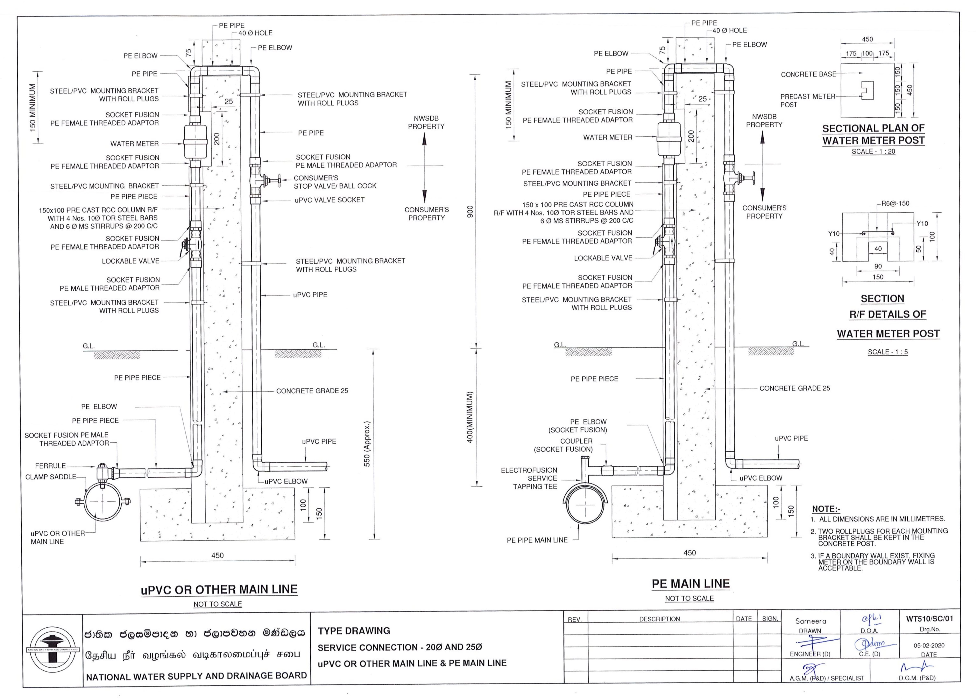
Revised on 16-11-2020

