**SPECIFICATION FOR PVC/ABS/STAINLESS STEEL/BRONZE/DI/CI VALVES, SHEAR GATES, SLIDE GATES AND MANHOLE COVERS &**

**FRAMES FOR SEWERAGE APPLICATIONS**

**TABLE OF CONTENTS**

|  |  |  |
| --- | --- | --- |
| 1 | General | 6x – 3 |
| 1.1  1.2  1.3  1.4  1.5  1.6  1.7  1.8 | Scope  Definitions  Reference Standards  Records and Drawings for Items  (Valves and other Ancillary items) to be supplied  Materials of Manufacture  Testing  Coating  Documents to be submitted | 6x – 3  6x –3  6x – 3  6x – 7  6x – 7  6x – 8  6x – 11  6x - 11 |
| 2 | Types of Valves | 6x – 11 |
| 2.1  2.2  2.3  2.4  2.5  2.6  2.7  2.7.1  2.7.2  2.7.3  2.7.4  2.7.5  2.8  2.9  2.9.1  2.9.2  2.9.3  2.9.4 | Sluice Valves  Cast Iron Gate Valves  Bronze Gate Valves  Knife Gate Valves  Shear Gates  Slide Gates  Check and Non-Return Valves  General  Check Valves  Ductile Iron Reflux / Check Valves  Bronze Check Valves  PVC and ABS Check Valves  Butterfly Valves  Ball Valves  General  PVC and ABS Ball Valves  Bronze Ball Valves  Stainless Steel Ball Valves | 6x – 11  6x – 13  6x – 13  6x – 14  6x – 14  6x – 15  6x – 16  6x – 16  6x – 16  6x – 16  6x – 17  6x – 17  6x – 17  6x – 19  6x – 19  6x –20  6x – 20  6x – 20 |

|  |  |  |
| --- | --- | --- |
| 2.10  2.11  2.12  2.12.1  2.12.2  2.12.3  2.12.4  2.13  2.13.1  2.13.2  2.14  2.15 | Diaphragm Valves  Solenoid Valves  Valve Actuators  Pneumatic Actuators  Hydraulic Actuators  Electric Multi-Turn Actuators  Manual Actuators  Air Valves  Single orifice Type  Double Orifice Type  Plug Valves  Flap Valves | 6x – 20  6x – 21  6x – 21  6x – 21  6x – 22  6x – 22  6x – 23  6x – 23  6x – 24  6x – 26  6x – 29  6x – 32 |
| 3 | Extension Spindles, Tee-Keys and Caps | 6x – 32 |
| 4 | Tools | 6x – 32 |
| 5 | Manhole Covers and Frames | 6x – 33 |
| 6 | Penstocks | 6x – 33 |

1. **General**

Valves shall be designed, supplied and installed as follows:

**Closing direction**: All valves shall close in clockwise direction.

**Valve size**: Generally, at least the normal pipe size.

**Hand wheels and handles**: Removable, with the direction of closing marked permanently on hand wheels.

**Working pressure**: All valve bodies shall be suitable for the maximum pressure as specified in the standard, which may be applied to the valve either as continuous or transient peak pressure, including test pressures.

**Insulated valves**: Provide extended shafts or bodies to butterfly and ball valves to allow full thickness of insulation.

**Connections**:

Valves< DN 50: Screwed to AS 1722.1 or ISO 7 or BS 21. All valves <DN50 shall have screwed three –piece unions with hexagon nipples for easy dismantling.

Valves > DN 50, valves in headers: Flanged to AS 2129 or BSEN 1092-2:1997.

**Resilient Seating Valves**: These valves types must not be used in situations where frequent operation against high unbalanced heads, high velocities orcavitations may be experienced.

**Below Ground Valves**: All electricity actuated valves and metering and monitoring equipment, which is located external to buildings and below ground, shall be located in concrete pits that can be easily accessed.

**1.1 Scope**

This section covers the requirements for the supply of valves and manhole covers. Accessories associated with the valves are also specified.

**1.2 Definitions**

The definitions given in the relevant standards, which are referred to in the specification, shall apply for the terms used in this specification.

**1.3 Reference Standards**

The following standards are referred to in this section;

ISO 7005-2:1988 Metallic flanges -- Part 2: Cast iron flanges

ISO 5211:2001 Industrial valves -- Part-turn actuator attachments

ISO 2084:1974 Pipeline flanges for general use -- Metric series -- Mating dimensions

BS 21:1985 Specification for pipe threads for tubes and fittings where pressure-tight joints are made on the threads (metric dimensions)

BSEN ISO 1461:2009 Hot dip galvanized coatings on fabricated iron and steel

articles. (Specifications & test methods)

BSEN 1982 : 2008 Copper and copper alloys. Ingots and castings.

BSEN 1092-1:2007 Flanges and their joint, circular flanges for pipes, valves, fittings and accessories PN designated.

BSEN 1092-2:1997 Flanges and their joints- Circular flanges for pipes, valves, fittings and accessories, PN designation

BSEN 1171 :2002 Industrial Valves. Cast Iron Gate Valves.

BSEN 12334:2001 Industrial valves, Cast iron check valves

BS EN 1563:2011 Founding. Spheroidal graphite cast irons

BSEN 593: 2004 Industrial Valves Metallic Butterfly valves.

BS 5163: 2004 Predominantly Key-operated cast iron gate valves for

Waterworks purposes (for wastewater application).

BSEN 10293: 2005 Steel castings for general engineering purposes

BS EN 124: 1994 Gully tops and manhole tops for vehicular and pedestrian areas. Design requirements; type testing, marking quality control.

BS 1212: Part 2 :1990 Diaphragm type float operated valves (copper alloy body) (excluding floats)

BSEN 558: 2008 Industrial Valves. Face to face and centre to face dimensions of metal valves for use in flange pipe systems. PN and class designated valves.

BSEN 1074 -1: 2000 Valves for water supply (for wastewater application). Fitness for purpose requirements and appropriate verification tests.

General Requirements.

BSEN 1074 -2: 2000 Valves for water supply (for wastewater application). Fitness for purpose requirements and appropriate verification tests. Isolating valves.

BSEN 1074 -3: 2000 Valves for water supply (for wastewater application).Fitness for purpose requirements and appropriate verification tests. Check valves.

BSEN 1074 -4: 2000 Valves for water supply (for wastewater application).

Fitness for purpose requirements and appropriate verification tests. Air valves

BS EN 12266-1:2012 Industrial valves. Testing of metallic valves. Pressure tests, test procedures and acceptance criteria. Mandatory requirements

BS EN 1563:2011 Founding. Spheroidal graphite cast irons

BS EN 10095:1999 Heat resisting steels and nickel alloys

BS EN 10250-4:2000 Open steel die forgings for general engineering purposes. Stainless steels

BS EN 10085:2001 Nitriding steel. Technical delivery conditions

PD 970:2005 Wrought steels for mechanical and allied engineering purposes. Requirements for carbon, carbon manganese and alloy hot worked or cold finished steels

BS EN 10087:1999 Free cutting steels. Technical delivery conditions for semi- finished products, hot rolled bars and rods

BS EN 10083-1:2006 Steels for quenching and tempering. General technical delivery conditions

BS EN 10084:2008 Case hardening steels. Technical delivery conditions

BS EN ISO 3834-1:2005 Quality requirements for fusion welding of metallic materials. Criteria for the selection of the appropriate level of quality requirements

BS EN ISO 3834-2:2005 Quality requirements for fusion welding of metallic materials. Comprehensive quality requirements

BS EN ISO 3834-3:2005 Quality requirements for fusion welding of metallic materials. Standard quality requirements

BS EN ISO 3834-4:2005 Quality requirements for fusion welding of metallic materials. Elementary quality requirements

BS EN 124:1994 Gully tops and manhole tops for vehicular and pedestrian areas. Design requirements, type testing, marking, control

BS ISO 1352:2011 Metallic materials. Torque-controlled fatigue testing

WIS 4-52-01 Class B Internal & External electro-statically applied blue epoxy

coating.

JIS B 0116:1978 Glossary of terms for packing and gaskets

JIS B 2001:1987 Nominal size and bore of valves

JIS B 2002:1987 Face-to-face and end-to-end dimensions of valves

JIS B 2003:1994 General rules for inspection of valves

JIS B 2004:1994 General rules for marking on valves

JIS B 2005:2004 Test procedures for flow coefficients of valves

JIS B 2031:1994 Gray cast iron valves

JIS B 2062:1994 Sluice valves for water works (wastewater application)

JIS B 2063:1994 Air vent valves for water works (wastewater application)

JIS B 2064:1994 Butterfly valves for water works (wastewater application)

JIS B 2220:2004 Steel pipe flanges

AS 1628:1999 Water supply (wastewater application)

- Metallic gate, globe and non-return valves

AS 5200 : 1996 Pinch valves

AS4795 : 2006 Double Flanged Butterfly Valve

AS 2638.2:1999 Sluice valves for water works (wastewater application)

[AS 1830-2007 Grey cast iron](http://infostore.saiglobal.com/store2/Details.aspx?ProductID=249276)

AS 2129-2000 Flanges for pipes, valves and fittings

AS 3578 -1993 Cast iron non- return valves for general purposes

AS 1628-1999 Water supply - Metallic gate, globe and non-return valves

AS/NZS 4087:2011 Metallic flanges for waterworks purposes

AS 1722.1-1975 Sealing Pipe Threads

**1.4 Records and Drawings for Items (Valves and other Ancillary items) to be supplied**

The following records and drawings of all types of valves shall be made available by the supplier for inspection.

* Drawings showing overall dimensions, valve construction and settings
* Data related to pressure ratings, weights and materials of manufacture (each , component)
* Test certificates of works tests
* Performance data of air valves
* Seating design and the seating materials of butterfly valves

**1.5 Materials of Manufacture**

All materials of manufacture shall be suitable for use with wastewater at temperatures up to 450C.

Valve body casting shall be ductile iron complying with BS EN 1563:2011 or JIS B 2062:1994 or AS 1628: 1995 for diameters above DN 150, while CI valve body casting is acceptable for below DN 150 and shall be capable of withstanding' the test pressures specified. The castings shall be close grained, sound, smooth and symmetrical, and shall be carefully cleaned and dressed off. No stopping or plugging will be permitted in the case of air holes appearing in the castings.

Unless otherwise specified, all standard valves shall be flanged type where flanges shall be of PN 16 and complying with BSEN 1092-2:1997 or JIS B 2062:1994 or AS 1628: 1995.

The direction of closing of valves shall be "clockwise" and hand wheels shall be permanently marked with the words "open" and "closed" and a direction arrow.

All materials shall comply with the appropriate British Standards or equivalent. All castings shall be free of blowholes and other defects.

Sluice valves and butterfly valves shall be suitable for flow in either direction.

All standard valves shall be suitable for frequent operation and for infrequent operation after long periods in the open or closed condition.

All non-metallic materials to be provided shall be listed in the current "Water Fittings   
and Materials Directory" published by the Water Research Centre, UK, or approved   
equivalent publication, as having passed full tests of effect on wastewater quality   
under the requirements for the testing of non-metallic materials for use in contact with

wastewater.

Purchaser shall have the right to reject any casting, forging, bearing etc and the

contractor shall replace any such defective parts at his own expense.

**1.6 Testing**

**General**

The manufacturer shall notify the Engineer at least thirty working days prior to factory tests. The Engineer reserves the right to witness all tests.

**Performance Test**

Each valve, gate and appurtenance shall be shop-operated three times from the fully closed to the fully opened position, and the reverse, under a no-flow condition, to demonstrate that the complete assembly is workable.

1. **Leakage Test (Closed Position)**
2. **For Internal Pressure**

Valves, gates and appurtenances shall be shop-tested for leaks in the closed   
positions. The hydrostatic pressure shall be applied to one face of the disc for   
the full test duration at the working pressure when the valve is in closed   
position. This shall be repeated to the other face of the valve too. The length of   
test shall be at least 3 minutes and there shall be no indication of leakage past   
the valve during the test period. The test pressure shall be given in the Table   
below.

|  |  |  |
| --- | --- | --- |
| **PN** | **Test Pressure (PFA) (Bars)** | **Duration (Minutes)** |
| 16 | 25 | 3 |
| 25 | 35 | 3 |

1. **For External Pressure**

Valves shall be leak tight to ingress of air, water or any other foreign matter.

1. **Hydrostatic Test**

Valves specified shall be hydrostatically tested. Hydrostatic tests shall conform to the following;

With the valve disc in fully open and a slightly open position, internal hydrostatic pressure equivalent to 150% of the specified working pressure specified in the table below shall be applied to the inside of the valve body of   
each valve for a period of 3 minutes. During the hydrostatic test, there shall be   
no leakage through the metal, the end joints, or the valve shaft seal; nor shall   
any part be permanently deformed. While undergoing testing, the valve body shall be struck with a hammer several times.

|  |  |  |
| --- | --- | --- |
| **PN** | **Test Pressure (PFA) (Bars)** | **Duration (Minutes)** |
| 16 | 25 | 3 |
| 25 | 35 | 3 |

**(iii) Seat Tightness Test**

|  |  |
| --- | --- |
| **Type of valve** | **Test procedure** |
| Sluice valve  Knife Gate Valve | 1. Fill in the valve cavity including if appropriate, the bonnet cavity with sewage. 2. Move the obturator to the closed position. 3. Apply the test pressure, which is 1.1 times the allowable differential pressure at room temperature, and maintain the rest pressure for 3 minutes. 4. Determine the leakage rate. 5. Repeat 3 and 4 inclusive for the other side of the valve.   See NOTES 1,2,3 and 4 |
| Butterfly Valve | 1. Fill the valve cavity with sewage. 2. Move the obturator to the closed position. 3. Apply the test pressure, which is 1.1 times the allowable differential pressure at room temperature in the direction to unseat the obturator and maintain the test pressure for 3 minutes. 4. Determine the leakage rate.   See NOTE 5 |
| Check Valve | 1. Fill the downstream valve cavity including, if appropriate, the cover cavity with sewage. 2. The test pressure, which is 1.1 times the allowable differential pressure at room temperature in the direction tending to close the obturator and maintain the rest pressure for 3 minutes. 3. Determine the leakage rate. |
| Air Valves | 1. Apply the test pressure of 140kPa and maintain it for 5min. 2. Observe for leakages. No leakage shall be allowed. 3. Apply the rated working pressure and maintain it for 5min. 4. Observe for leakages. No leakage shall be allowed. |
| **NOTE**   1. The procedure described may not ensure pressurization of the integrate space of double seated valves and may not therefore permit verification of the leakage rate of the downstream seat. When such pressurization is a requirement of the product or performance standard or is required by the purchaser, it is necessary to carry out step 3 before step 2. 2. Valves which incorporate “double block and bleed” design feature have the bleed plug removed prior to the test in order to prove the “double block and bleed” capability. 3. Valves with independent double seating (such as two piece obturator or double-seated valves) may be tested by applying the test pressure between the seats and checking each side of the closed valves. 4. Soft seated ball float valves previously subjected to a liquid seat test pressure may have a reduced performance capability in some subsequent services at low differential pressures. If a liquid seat test pressure is specified and is carried out before a low pressure gas seat test, it may be necessary to allow time for the seat material cover. 5. Valves with symmetrical seating may be tested in either direction. | |

**(iv) Field Testing**

When the valves, gates and appurtenances have been completely installed and as soon as operation conditions permit, they shall be given a field test by the Engineer to demonstrate that they have been suitably installed, that they meet all requirements, are in good operating condition and are, in every way, adequate for the service intended.

**1.7 Coating**

All exposed cast iron or ductile iron components of valves to the external environment or to the water contained in the valve shall be fully coated to provide protection against corrosion.

The external and internal surfaces except mating surfaces of all valves shall be treated with an epoxy coating, a bitumen solution or any other material acceptable to the purchaser at the place of manufacture. Threaded and exposed machined surfaces liable to rusting shall be adequately protected in accordance with BS 5163 : 2004 or in compliance to WIS 4-52-01 Class B.

**1.8 Documents to be submitted**

The following documents shall be submitted to assess the quality of the materials

* Quality management certificates operated by the manufacturer
* Product conformity certificate
* Test certificates
* Conformity certificate for the manufacturer’s trade mark
* Manufacturer’s catalogue(original)
* *Design engineer shall provide operating pressure, back pressure during filling of pipeline, size of the pipeline, air discharge rate and rate at which air to be admitted during emptying the pipeline for deciding types ofair vale.*

1. **Types of Valves**

**2.1 Sluice Valves**

The sluice valves for pipeline installation shall comply with the BSEN 1074:1-2000   
and BSEN 1074 : 2 - 2000 or BS 5163-1:2004 or JIS B 2062:1994 or AS2638.2:1999 for diameters up to and including 600 mm and BSEN 1171:2002 for diameters above 600 mm and shall be of PN 16 pressure rating, for wastewater applications.

Sluice valves shall be standard inside screw, wedge gate valves with resilient seating   
for diameter from DN 50 - DN 300 inclusive and metal to metal seating from   
diameters above DN 300 The valve body shall be ductile iron or cast iron upto and including DN 150 complying with BS 5163-1 : 2004 or JIS B 2062:1994 or AS2638.2:1999 and BSEN 5163 : 2004. For diameters above 150mm, the valve body shall be ductile iron complying with BSEN 5163: 2004. Valves shall have stainless steel stems, machined bronze or gunmetal mating faces securely fixed to the valve body, stuffing box and gland type or approved type stem seal, EPDM / SBR seals at joints between castings.

All valves shall be coated internally and externally with Rilsan ‘Nylon 11’ (or similar copolymer) and fitted with O-ring stem seals, rubber seal wedges and brass stems. All valves shall bear the inspection stamp of a recognized testing authority.

All Tee-Key operated (underground) valves shall be provided with valve cap as per BS 5163 : 2004 or JIS B 2062:1994 or AS2638.2:1999. By pass arrangement shall be provided for valves of DN 300 and above. Directions of closure of the valves shall be `clockwise". In case of hand wheel operated (above ground)valves, the hand wheels shall be indelibly marked with words "open" and "close" with direction arrows.

The maximum differential pressure in operation for valves shall be as given in items description of the valves in the BOQ or as given in the drawings. Where necessary valves above 300mm diameter shall be provided with gearing to achieve the designed manual operation of valves where it should be assumed that the maximum torque exerted by one man is 130 Nm.

Motorized (Motor operated) valves shall be provided for diameters 500mm and above as given in the item description of BOQ or as given in the drawings.

Valve spindles shall be of the internal non-rising type. Hand wheels shall be made of cast iron and shall have arrows and words `open' and `close' cast on to indicate direction of rotation for opening and closing the valve.

All sluice valves shall be subjected to all type testing in accordance clause 1.6 above including 'open ended' works test of which the test certificates issued by the manufacturer to this effect, shall be submitted.

**The face-to-face (FTF) dimensions of the sluice valves as specified in BSEN 558:2008 shall be as follows. (Sluice Valves – Series 3)**

|  |  |  |
| --- | --- | --- |
| **Diameter (mm)** | **FTF dimension (mm)** | |
| **PN 10 / PN 16** | **PN 25** |
| 10 | 102 | - |
| 15 | 108 | 140 |
| 20 | 117 | 152 |
| 25 | 127 | 165 |
| 32 | 140 | 178 |
| 40 | 165 | 190 |
| 50 | 178 | 216 |
| 65 | 190 | 241 |
| 80 | 203 | 283 |
| 100 | 229 | 305 |
| 125 | 254 | 381 |
| 150 | 267 | 403 |
| 200 | 292 | 419 |
| 250 | 330 | 457 |
| 300 | 356 | 502 |
| 350 | 381 | 572 |
| 400 | 406 | 610 |
| 450 | 432 | 660 |
| 500 | 457 | 711 |
| 600 | 508 | 787 |
| 700 | 610 | - |
| 800 | 660 | - |
| 900 | 711 | - |
| 1000 | 813 | - |

**2.2Cast Iron Gate Valves**

All cast iron gate valves shall be of heavy-duty design and are to be of the non-rising stem type. Valve body, hand wheel and bonnet to be of ductile cast iron (spheroidal graphite C.I). Non-rising stems to be of brass (Mang. Bronze). Wedge, body seat rings and disk seat rings to be from Gunmetal or Bronze. Flanged cast iron valves shall be in accordance with AS 1830:2007 or BSEN 1074 -1:2000 & BSEN 1092 -2:1997 or ISO 7005 -2: 1998.

**2.3 Bronze Gate Valves**

All bronze gate valves shall be manufactured from dezincification resistant bronze, inside screw, non-rising stem and screwed bonnet, in accordance with AS 2638 or BSEN 1074 -1:2000 & BSEN 1092 -2:1997 or ISO 7005 -2: 1998 or JIS B 2062:1994.

**2.4 Knife Gate Valves**

Knife gate valves are used mainly for isolation duties in both clean and dirty water applications.

The valves shall be suitable for the following applications.

Above ground or set in chamber submerged duty.

Valves shall be fitted with an elastomer seal suitable for flow in either direction and shall be leak tight in both directions. The seal material shall be suitable for use with wastewater and resistant to chlorine at solution strengths of 40 ppm.

Valve bodies shall be capable of withstanding 1.5 times the rated pressure with the gate open, and the rated pressure with the gate-closed. Flanges shall be to BS EN 1092-2:1997 or JIS B2220:2004 or AS2129:2000.

Valves are to close when the spindle is turned in a clockwise direction.

Materials of construction shall be corrosion resistant, be compatible with all forms of sewage and be approved for use with potable water.

Materials of construction shall be selected to avoid electrolytic corrosion and, erosion.

To prevent corrosion on submerged duties, the internal and external surfaces of the valve body shall be coated with an approved coating to WIS - 4-52-01 or better.

Valves for above ground duty may have soft packing type spindle seals, but valves for   
submerged duty shall have seals fitted that prevent leakage and the ingress of contaminants.

Valves shall be designed to allow stem seals to be repacked or replaced with the gate in the fully open position and under full mains pressure.

Actuated valves shall incorporate a robust guide mechanism to ensure shaft alignment under all operational scenarios.

For hand operation the valves shall be fitted with a cap suitable for use with a key and bar, or a hand wheel where specified.

For power operation, provision shall be made for fitting electric actuators where specified.

**2.5 Shear Gates**

Shear gates shall be suitable for isolating and emptying sewage manholes and other similar pits, by installation on the sidewall and with manual operation from surface level. The gate shall be of the wedge type to facilitate tighter closing and better isolation. Wedges shall be removable by unbolting, for easy replacement due to wear.

Materials shall be as follows:

* Frame and cover shall be from cast iron;
* Lifting rod shall be from galvanized steel pipe;
* Wedges, wedge seats and bolts shall be from bronze;
* All other trim shall be from bronze;
* Fixing to pit wall shall be 316 SS chemical anchors.

**2.6 Slide Gates**

Slide gates shall be designed for the specific installation with on or off seating (for rising and non-rising) capability as appropriate and fixing as appropriate. Slide gates shall be self-contained so that no actuation loads are transmitted to the concrete structure unless the stem passes through a concrete slab.

In general the slide gate shall be grade 316 stainless steel, unless otherwise specified. Bolts and fasteners shall be grade 316 stainless steel. All welding shall be passivated or cleaned to remove all evidence of weld scorching. Stainless steel shall be isolated from aluminum with plastic sleeves and washers. The gate or door shall be fabricated from grade 316 stainless steel plate suitably stiffened if required. Side guides shall be provided over its full travel. All components shall be designed for maximum deflection of L/720 for worst-case loads. Off-seating wedges shall be provided where required.

Side and top seals shall be neoprene or UHMW polyethylene with neoprene backing unless otherwise specified. They shall be under compression and shall be readily replaceable. The bottom seal shall be flush with the floor of the channel and shall be of resilient material such as polyurethane or neoprene and shall not be less than 20mm thick or 20mm wide. Downward opening weir slide gates shall have bottom seals the same as side seals. All seals shall be fastened, not glued, in place.

The stem shall be not less than 28mm diameter but in any case shall not have a slenderness ratio (L/r) greater than 200. A limit nut shall be supplied and set such that excessive force applied by the operator at closure cannot buckle the stem. The limit nut shall be cast iron , bronze or grade 316 stainless steel. The stem shall be rising. The stem thread shall be ACME or stub ACME. The stem shall be constructed of grade 316 stainless steel.

Manual hand wheels or cranks shall be designed with maximum input of 180N at maximum operating conditions. Finish shall be two pack epoxy or fusion-bonded epoxy. All stems shall have clear polycarbonate stem covers with capped tops. Hand wheels or crank handles shall be installed at a height that ensures the gate can be raised above water level, but shall be a minimum of 1000mm above the operating floor level.

The minimum bolt size including seal pressure adjustment shall be M12 except for any seal fasteners.

**2.7 Check and Non-Return Valves**

**2.7.1General**

Non-return valves shall be provided and installed as follows:

* Installed on all pipelines where backflow prevention is required;
* At least 6 pipe diameters of straight pipe on the upstream side of any non-return valve;
* Sized to achieve a through flow velocity of no more than two (2) metres per second;
* Isolation valves shall be provided for all non-return valves. A dismantling joint shall be provided between the isolating valves to allow the non-return valve to be removed. Where required, the dismantling joint shall be thrust transmitting;
* Installed between horizontally laid pipe work;
* Swing check non-return valves shall comply with AS 3578:1993or BSEN 12334:2001 and be suitable for use in horizontal pipelines. Swing check valves shall be fitted with extended shafts and counterweights suitable for the fitting of flow switches where required;
* Valves shall be coated internally and externally with a thermal-bonded polymeric coating.

**2.7.2 Check Valves**

Unless otherwise specified, check valves shall be swing type conforming to BSEN12334:2001 or AS1628:1999 with a pressure rating of PN16 (i.e.16 bar). Check valves shall be constructed so that disc, seat, seat rings and other internal working parts, which may become necessary for repairs, shall be readily accessible, removable and replaceable without use of special tools and removing the valve from the line. The valve body and the disc shall be of ductile iron complying with BSEN1563:2011 and having smooth operating stainless steel hinge pins with gun metal bushes, EPDM / SBR encapsulated discs. They shall possess high speed closing characteristics with minimum shock on closing. All valves shall be tested to BSEN12334:2001 or AS1628:1999 and as specified in BSEN 12266-1:2012 and the test certificates issued by the manufacturer shall be submitted. All check valves shall be coated to as specified in clause 1.7 above. The flange drilling shall comply with BSEN 1092-2:1997, BSEN 1092-2:2007 or BSEN 1092-3:2003.

**2.7.3Ductile Iron Reflux / Check Valves**

All check valves shall be cast iron body, cast iron flap,. swing check valves, fitted with an external leverarm and adjustable counterweight and shall incorporate a cam and cam operated weatherproof micro-switch and mounting bracket, entirely suitable for use in water or sewerage pressure mains.

The valves shall feature replaceable seat in the body and stainless steel shaft. The bolted cap shall feature a plugged pressure tapping.

All valves shall be coated internally and externally with Rilsan 'Nylon 11' (or similar).

All studs shall be 316 stainless steel. All nut and bolt sets shall be hot dip galvanised.

**2.7.4Bronze Check Valves**

All bronze check valves shall be swing check valve manufactured from dezincification resistant bronze, screwed cover, in accordance with AS 1628 or BSEN 12328.

**2.7.5PVC and ABS Check Valves**

Valves shall be ball check and of compact design.

Material shall be complete plastic (PVC or ABS) body and ball, resistant to corrosion from the fluids they service.

Valves shall be provided with a union at one end to permit removal and dismantling. Construction should suit both threaded and flanged adaptors. Union ring nuts and o-rings shall comply with DIN. Seats shall be from EDPM or PTFE (Teflon) with Neoprene Seals. Valves shall be rated for pressures up to 10 bar working pressure and temperature of 60°C.

**2.8 Butterfly Valves**

Standard butterfly valves shall conform to BS EN 593: 2004 or JIS B 2064:1994 or AS4795:2006 for PN 16 (i.e. 16 bar)pressure rating. However higher PN range shall be provided as given in the item of BOQ.

Except where otherwise specified, all butterfly valves shall be equipped with manual operators with hand wheels and shall be resilient seated and shall give tight closure against unbalanced water pressure in either direction. The unbalanced water pressure shall be the design pressure rating of the valve.

The valve body shall be ductile iron complying with BS EN 1563 : 2011 and shall be designed to withstand the maximum working pressure specified and the maximum differential pressure of 0.6 MPa.

The manufacturer's preferred direction of flow for the valve shall be clearly marked on it.

The valve seat shall be replaceable and be formed of EPDM/SBR or other approved resilient material. Seats shall be of a design that permits removal and replacements at the site of installation. The valve seat shall be securely clamped into a machined groove in the valve body or to the edge of the disc by seat retention members or other equivalent retention device, in such a manner as to prevent leakage of water under the seats and to hold the seat securely in position during opening and closing of the valve disc. The seat retention members shall be of stainless steel and shall be securely fastened to the body or disc with stainless steel fasteners.

The valve disc shall be made of ductile iron. Disc edges shall be machined with rounded corners and shall be polished to a smooth finish. The valve disc shall rotate through an angle of 90 degrees from the fully opened to the fully closed position and the seat shall be of such design as to allow the valve disc to seat at an angle normal to the axis of the pipe when the disc is in the fully closed position. Adjustable mechanical stops shall be provided in the valve body to be capable of absorbing full operating torque with a minimum design safety factor of 5 (five).

The shaft and nuts and bolts shall be fabricated of stainless steel complying with   
relevant standards in the listed specifications. The shaft and disc fixing shall be capable of   
absorbing the full operating torque with a minimum design safety factor of five. Shaft   
seals, when used, shall be EPDM / SBR rubber O-ring type. Packing shall be either rubber O-ring or self-adjusting chevron type.

When all the seat retention members are in place, the finished edges shall fit closely and the surface shall be smooth with all fastenings set flush in the water passage so as to offer the least resistance possible to the flow of water through the valve.

Valve seats which extend over the face of the flanges to secure the seat in place, or which require surface grinding and/or hand fitting of the disc; or designs which require the adjoining pipe flange to retain the seat in place and resist line pressure, shall not be supplied.

Operating gear for butterfly valves shall be of the fully enclosed type. Valves shall be   
suitable for operation by one man at all pressure conditions that can apply. A valve   
position indicator shall be provided for butterfly valves in chambers. Where a hand   
wheel is used for operating such a valve, the indicator shall be clearly visible from the   
hand wheel operating position. Where a containing chamber is not shown, butterfly   
valves shall be specially adapted for buried use. Inline valves shall be operated by   
means of a hand wheel or tee key and be provided with gearing to prevent rapid   
closure of the valve. Gear ratios shall be at least 20:1. The valve bodies shall be   
protected by a bitumen coating and the valve discs by a Nylon Coating or similar.

All butterfly valves shall be tested at the manufacturer's works in accordance with BS   
EN 593:2004 as specified here and as per clause 1.6 above and under 'open-end' conditions. The seat test shall be for tight closure under maximum unbalanced water   
test pressure in either direction. The maximum permissible leakage for each valve shall be 0.05liter per hour per 100 mm nominal diameter of the valve. The word "CLOSE" or its abbreviation and the arrow mark indicating the direction of rotation to close the valve shall also be cast on the cover of the body.

**The face-to-face (FTF) dimensions of the sluice valves as specified in BSEN 558:2008, Table 4 shall be as follows**

|  |  |  |  |
| --- | --- | --- | --- |
| **Diameter (mm)** | **FTF dimension (mm)** | | |
| **PN 2, 5, 6, 10, 16, 25** | | **PN 40** |
| 40 | 106 | 140 | 140 |
| 50 | 108 | 150 | 150 |
| 65 | 112 | 170 | 170 |
| 80 | 114 | 180 | 180 |
| 100 | 127 | 190 | 190 |
| 125 | 140 | 200 | 200 |
| 150 | 140 | 210 | 210 |
| 200 | 152 | 230 | 230 |
| 250 | 165 | 250 | 250 |
| 300 | 178 | 270 | 270 |
| 350 | 190 | 290 | 290 |
| 400 | 216 | 310 | 310 |
| 450 | 222 | 330 | 330 |
| 500 | 229 | 350 | 350 |
| 600 | 267 | 390 | 390 |
| 700 | 292 | 430 | 430 |
| 800 | 318 | 470 | 470 |
| 900 | 330 | 510 | 510 |
| 1000 | 410 | 550 | 550 |
| 1200 | 470 | 630 | 630 |
| 1400 | 530 | 710 | 710 |
| 1600 | 600 | 790 | 790 |
| 1800 | 670 | 870 | 870 |
| 2000 | 760 | 950 | 950 |

**2.9 Ball Valves**

**2.9.1General**

Unless otherwise approved by the Superintendent's Representative, ball valves shall be:

* Full bore three piece construction with Grade 316 stainless steel body, trim and fasteners, for full in line applications.
* May be reduced bore construction only for isolation purpose applications.
* Seats and seals shall be PTFE unless otherwise specified.
* Pressure rated to a minimum of 1200 kPa.

**2.9.2 PVC and ABS Ball Valves**

Where approved, valves shall be manually operated, 2-way, double union body, ball valves of compact design.

Material shall be complete plastic (PVC or ABS) body, ball and stem, resistant to corrosion from the fluids they service.

Valves shall be provided with unions on both ends to permit removal and dismantling. Construction should suit both threaded and flanged adaptors.

Union ring nuts and o-rings shall comply with DIN.

Seats shall be from EDPM or PTFE (Teflon) with Neoprene Seals unless otherwise specified.   
Valves shall be rated for pressures up to 10 bar working pressure and temperature of 60°C.

**2.9.3 Bronze Ball Valves**

Where approved, valves shall be "Top Entry", one-piece body, regular bore, quarter turn, ball valves.

Materials shall be bronze body, with stainless steel stem and ball, reinforced PTFE (Teflon) seats and PTFE stem seal.

End connections shall be flanged to AS 4087 class 16.

Pressure and temperature ratings shall equal 35 Baranq 260°C.

**2.9.4 Stainless Steel Ball Valves**

These valves are for use on sampling lines throughout the plant. Valves shall be three-piece, full bore, quarter turn, ball valves of dropout design, with PTFE seats and stem seals unless otherwise specified.

Materials shall be 316 stainless steel body, connections and trim.

Valves shall be rated for pressures up to 56 bar working pressure and temperature of 230°C.   
End connections shall be BSP (Female) fittings at both ends, unless otherwise specified.

**2.10 Diaphragm Valves**

Diaphragm valves shall be of the straight-through, full-bore type, designed for sludge and abrasive slurries, such as the 'Saunders KB series', Glenfield, AVK, Biwater etc. or similar approved.

The valve body shall be of cast or ductile iron and shall be finished in a corrosion protective coating of either Neoprene or Butyl.

The valves shall be fitted with a hand wheel and a position indicator. The stem and compressor shall be housed in a completely sealed, lubricated assembly, designed to provide long term maintenance free operation.

Diaphragms shall be of the resilient type, made of Nitrile rubber. Body ends shall be screwed.

The valves shall be installed in such a manner so as to facilitate disconnection of lines for maintenance purposes or in the event of a blockage.

**2.11 Solenoid Valves**

Solenoid valves shall be bronze body, pilot operated packless valves with weatherproof IP56 solenoids rated for 24 VDC (or 240 V, 50 Hz), normally closed, suitable for operation on pressure between 30 kPa and 1000 kPa.

Coils shall have Class H insulation and rated for continuous duty. The solenoid .valves shall be 'SMC' or equivalent with Grade 316 stainless steel body with tapered BSP threads.

Solenoid valves shall be suitable for air and water service, of the size and type of operation required for the particular application, and shall be capable of manual operation.

**2.12 Valve Actuators**

**2.12.1 Pneumatic Actuators**

Pneumatic actuators shall be double acting, quarter turn, rack and pinion actuators, unless otherwise specified. Knife Gate valves and the like shall use double acting, pneumatic cylinder actuators.

The valve/actuator assembly shall incorporate a single, directly operated, 24 Volt DC, solenoid valve (of type 316 SS construction) pneumatically connected in series between the air supply connection and actuator. When energised, this valve will allow air supply to the valve actuator to operate the valve. When de-energised it will block the air supply and vent the actuator pressure to allow the valve to return to its fail-safe position as indicated in the instrument data sheet.

Actuators and accessories shall be suitable for operation based on minimum air system pressure of 500kPa.

Valve speed control shall be achieved by the use of fixed orifices. The use of needle valves or speed regulators shall not be used unless approved by the Superintendent.

A facility shall be provided to manually operate the valve (open and close) whilst the solenoid valve is energized. This will be achieved via an upstream, manual 3-way valve, connected in series with the solenoid. Thus, the manual open function will not be available when the solenoid valve is de-energized.

Two instrument check valves shall also be installed in series and upstream of the above-mentioned 3 -way valve. This will prevent depressurization upon loss of the instrument air supply system.

All actuators must be equipped with open and close limit switches, preferably proximity type switches. Each switch must indicate when the valve is fully open or closed.

**2.12.2 Hydraulic Actuators**

The valve shall be fitted with a double acting cylinder actuator which shall be used for automatic valve operation. The actuator shall be sized to operate the valve with a supply pressure range of 170kPa to 300 kPa.

Actuators and accessories shall be suitable for operation based on full hydraulic system pressure.

Valve speed control shall be achieved by the use of fixed orifices. The use of needle valves or speed regulators shall not be used unless approved by the Superintendent. Valve operation shall be controlled using a 24-volt DC spring return solenoid valve with the spring

providing fail-safe valve closure upon hydraulic power supply failure.

Hydraulic piping shall be rigid 316 stainless steel tubes. Tube connections shall be with compression fittings with metal ferules.

Fail-safe operation of the actuator shall not rely on the use of hydraulic accumulators.

**2.12.3 Electric Multi-Turn Actuators**

Actuators shall be 415 volt, 50Hz, AC on-off, Bi-directional, Multi-turn electrically controlled with permanent gear override facility, torque travel limit switches and visual position indicator or approved equivalent.

Extension assemblies with appropriate bracing to adjacent structures shall be provided to ensure that electric actuators are raised above level of possible water immersion.

The electric valve actuator shall be a three-phase unit incorporating electrical motor, integral reversing starter, gearbox, and control gear in an integral IP 65 enclosure.

The starter shall be suitable for the environmental conditions.

The enclosure shall be o-ring sealed, watertight, and fitted with an integral compartment heater.

The electric motor shall be high torque, rated for frequent starting in 40 degree C ambient, fitted with over temperature, stall, and single phasing protection.

The gearbox shall be totally enclosed, oil lubricated with bearings suitable for valve thrust loads. Manual operation shall be provided by clutch and hand wheel, with auto-reset function.

The valve shall include adjustable torque limit, position limit switches, local mechanical position indicator and remote position indicator by 4-20 mA transmitter.

The indication switches shall include open, closed, motor protection operated, torque limit, and manual engaged.

An integral local control and control mode selector to facilitate opening, closing, and lockout of the actuator shall be included.

Remote control shall be by following a 4-20 mA control signal from the PLC, with the valve position proportional to the control signal.

**2.12.4 Manual Actuators**

Manual actuation of larger valves or penstocks is not acceptable unless otherwise specified.

Where manual actuation is specified, each manual actuator shall include all necessary gearing, couplings, gear case, guards, spindles and hand wheels. Hand wheels shall be fitted to the vertical spindle by means of a square key drive and a guard shall protect the vertical spindle. The hand wheel shall have an arrow and the word "open" indicating the direction of rotation. The maximum torque required at the hand wheel shall not exceed 130 Nm under the worst conditions of differential head or unseating force.

Operating hand wheels shall be located in a readily accessible position with the centerline of the hand wheel between 900 mm and 1200 mm above the floor level. Where hand wheels cannot be readily reached a chain wheel type operator shall be provided. The chain shall extend to within 1000 mm of the floor level or operating platform.

Where valves or penstocks are not provided with fixed actuators, consideration shall be given to the use of a portable actuator, which can service a number of non-actuated valves. In such cases, geared spindles etc will be provided to facilitate the portable actuator.

**2.13 Air Valves**

All air valves for sewage application shall comply with the BSEN 1074-4:2000. Air valves   
shall be constructed so that internal working parts, which may become necessary for   
repairs shall be readily accessible, removable and replaceable without use of special   
tools and removing the valve from the line. Standard air valves shall be designed so   
that the floats seat against orifices without leakage at all pressures between 0.1 bar and the maximum field test pressure. The design for the floats and seats shall be such   
that the risk of adhesion is a minimum and shall be of a type proved by experience to   
be suitable for the duties required. All valves shall be suitable for operation under   
working pressures conforming to clause 4.3 and Table I of BSEN 1074-1:2000, Valves shall be so designed that the floats cannot be held or blown shut against the orifices by air pressure or turbulence due to escaping air.

Standard air valves shall have a minimum pressure rating of 16 bar and in all cases   
shall be supplied with PN 16 (i.e. 16 bar) flanges, complying with BS EN 1092-2:1997or AS2129:2000.

However higher PN range shall be provided as given in the item of BOQ.

**2.13.1 Single orifice Type**

**(a) Small Orifice Air Valves**

Single orifice type air valve shall be of cast iron or ductile iron body and single float actuated air valves with flanged ends. Small orifice air valves shall have an orifice diameter of not less than 1.5mm and shall be designed for automatically releasing air accumulated in pipelines during normal working conditions so as to prevent accumulations of air interfering with pipeline capacity. Small orifice air valves shall be provided with an isolating valve.

The valve shall be capable of discharging air out of the pipe line in according to the graph given below.

**Graph 01: Air Discharge of Single Orifice (Small Orifice) Air Valve**

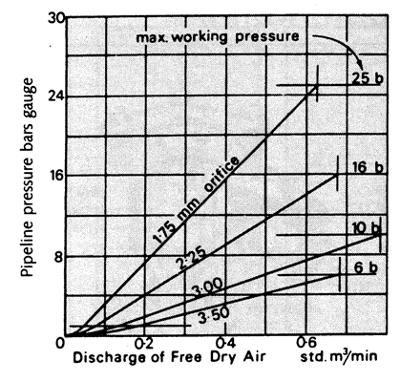

1. **Large Orifice Air Valves**

Large orifice air valves shall be required to release or admit air while the pipeline is being filled or emptied and also to perform surge control functions. The airflow characteristics of air valves shall be in accordance with BSEN 1074-4:2000 and they shall be capable of passing air out of the pipeline under a differential pressure of 0.5 bar, and into the pipeline at a differential pressure of 0.2 bar at rates depending on the graph given below;.

**Graph 02:Air Discharge of Single orifice (Large Orifice) Air Valve**

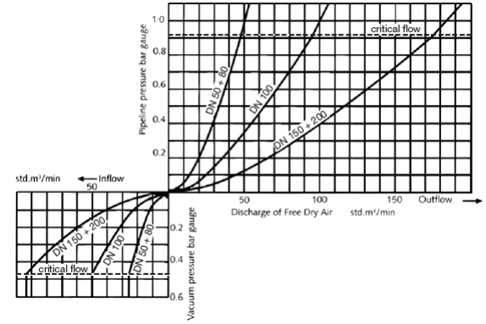

**Graph 03:Air Discharge of Single orifice (Large Orifice) Air Valve**

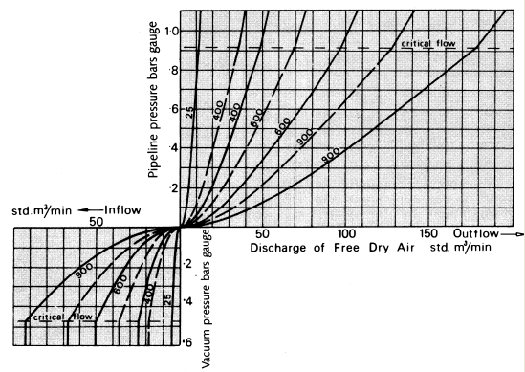

* Broken curves for air valves with a lugged isolating butterfly valve and stud bolts
* Full curves for all other air valves

**Figure 01: General Components of the Single Orifice Air Valve**

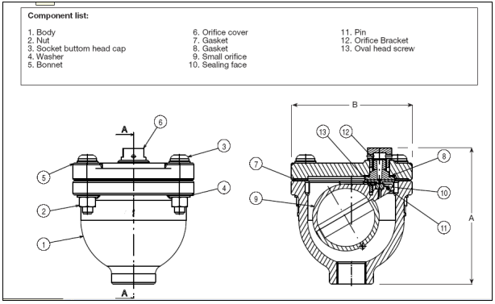

**2.13.2 Double Orifice Type**

Double orifice valves shall comprise one large orifice air valve and one small orifice   
air valve integrated into a single unit assembly and having a single pipeline   
connection. It shall have cast iron or ductile iron body and double float actuated air

valves with flanged ends.

Double orifice air valves shall be provided with a separate isolating valve. Isolating   
valves must be so arranged that they can be closed from the ground surface above,   
with a tee key even when the air valve chamber is flooded. Where required, a short   
length of double-flanged pipe could be supplied to increase the height above the main   
to suit the operational requirements depending on the depth of installation of Air   
valve. Air valves shall be insect proof at the outlet vents leading to the atmosphere.

Tests shall be carried out on all types of air valves, as specified in BSEN 1074-4:2000 and BSEN 1074-1:2000 and as mentioned below and the contractor shall submit the manufacturer's certificates certifying that such tests have been conducted satisfactorily.

The valve shall be capable of discharging air out of the pipe line in according to the graph given below.

**Graph 04:Discharge /Inflow Capacities of Air Valves (Double, Triple & Quadruple Clusters)**

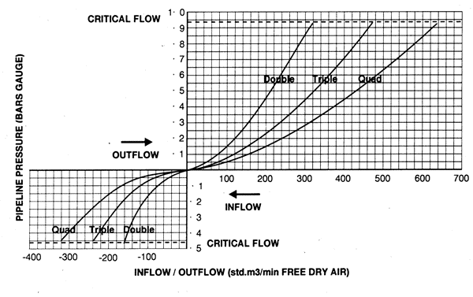

**Figure 02: General Components of the Double Orifice Air Valve**

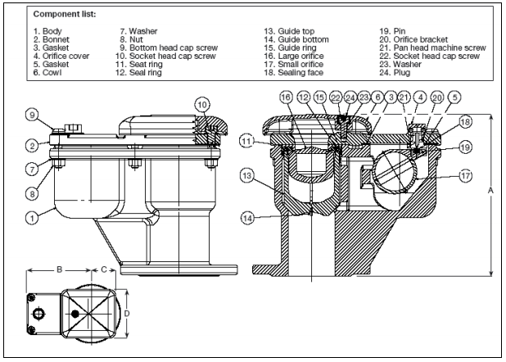

1. **Body Strength Test**

Each complete valve shall be water tested for strength using a test pressure 1.5 times the specified working pressure. No damage or permanent deformation of the valve body, ball or seat shall occur and there shall be no leakage through the metal or any joints of the body.

1. **Leakage Test**

Each complete valve shall be water tested at all pressures between 0.1 bar and the maximum field test pressure for the valve and the seat shall be drop tight throughout this range of pressure.

1. **Performance Tests**

One valve of each size shall be tested as follows;

(i) Air shall be introduced under the flange at the minimum outflow rate specified above for the size of pipeline being tested. The pressure difference required to maintain this flow shall not be more than 0.5bars.

(ii)Air shall be exhausted from beneath the flange at the minimum inflow rate specified above for the size of valve being tested. The pressure difference required to maintain this flow shall not exceed 0.2 bars.

All air valves shall be coated as given in clause 1.7 above.

**2.14 Plug Valves**

Plug valves shall be designed for sewerage applications, offer corrosion resistance and allow ease of maintenance. The body shall be made of 316 stainless steel or carbon steel or Alloy 20 and process applications including two-way, three-way, jacketed, flush-through and double block and bleed valves. The valve shall feature a pressure relief hole in the plug that allows flushing of the lower cavity.

The valve shall have an external indication of seat wear for operators to easily determine the seat wear when contact is made and wiping action of the plug on the raised seats. In addition, the valves shall have self adjusting plug to compensate seat wear.

All actuator top mounting pads/adapter brackets shall be in accordance with ISO5211 standard. Flanges shall be compatible with BSEN 1092-1:2007 and BSEN 1092-2:1997 or ISO 2084.

**Fig 03: General Components of Plug Valves**

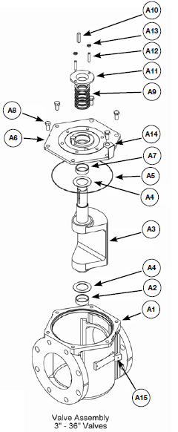

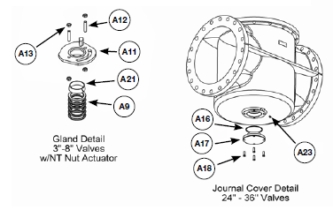

**Material of Construction**

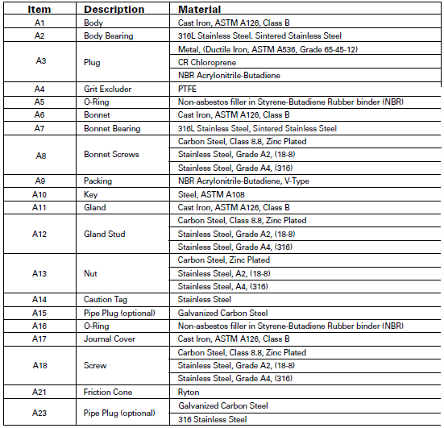

**2.15 Flap Valves**

Flap valves shall have frames and doors of ductile iron to BS EN 1563 : 1997, sealing faces of gunmetal to BS EN 1982:2008Grade.LG 2 or LG 4 and hinge pins and links of ductile iron, steel nickel iron or stainless steel. They shall be flanged for mounting to pipe work or bolting to concrete. Sealing surfaces of flaps and frames shall be of non-ferrous metal (excluding aluminum) accurately machined to ensure a watertight fit in the closed position. All flaps shall be double hung and seat off the vertical.

In case of plastic flap valves they shall have doors constructed from non-toxic,   
ultraviolet stabilized, flexible reinforced plastic material and the frames shall be fabricated from mild steel, blast cleaned and painted with 25 microns of two pack epoxy blast primer and one 75 micron coat of micaceous iron oxide two pack epoxy.

All immersed steelwork shall be hot dipped galvanized to BS 729 or as appropriate. Nuts and bolts shall be galvanized. Flanges shall be of PN 16 conforming to BS EN 1092 - I :2007., coated in either fusion bonded epoxy, minimum thickness 150 microns or cold applied black bitumen.

1. **Extension Spindles, Tee-Keys and Caps**

The depths of installation of all valves are as indicated in the BOQ descriptions (or as shown on the drawings) and a Tee - Key for the operation of valves shall be supplied in the following manner.

Four Tee - Keys for each size of valves to be supplied. The maximum length of Tee key shall be limited to I m and Valves shall be provided with extended spindle to the Valve.

The material of Tee - Keys shall be galvanized mild steel.

In case extension spindles are necessary, extension spindles shall be provided with suitable bearings, which are rigidly held on brackets or stays. Bearings and extension spindles shall be suitably protected against corrosion.

Where a valve does not require an operating or extension spindle, the valve spindle shall be protected with a properly fitting cap as per BS 5163: 2004.

1. **Tools**

The Contractor shall supply two complete sets of tools adequate for the erection and maintenance of all valves, hydrants and other fittings supplied.

1. **Manhole Covers and Frames**

Manhole covers and frames shall be of class D 400 as per BS EN 124: 1994 unless otherwise stated. They shall be made from Ductile Iron.

The covers shall be non-ventilating non rock, black bitumen coated. The keyways shall be closed and the couplings bolts, etc. shall be galvanized.

All the manhole covers shall be water tight.

They shall be with clear opening of 600 mm, with captive hinge arrangement to prevent vandals and with suitable watertight arrangement to prevent ingress of surface water into the manhole.

Manhole covers for air valves and washouts shall be ventilated type. The manhole covers for sluice valves shall be watertight.

The manhole covers shall have letter or words in English to indicate the function of the fitting, "AV, SV" and also marking "NWSDB - SEWER" in suitable size, cast in raised letters.

1. **Penstocks**

All penstocks shall be of the flat back type and shall be drop-tight in the ranges of duty for which they are required.

Penstocks, frames and doors shall be of best quality cast iron complying with BS 1352:2011with two annular gunmetal sealing faces on frame and door. An adequate number of cast iron wedges shall be provided on the doors of adjustable gunmetal faced wedge blocks as necessary fixed to the frames. The frame shall be of substantial construction.

The gunmetal shall comply with the requirements of BS 1982:2008.

All screw penstocks shall be provided with a mild steel spindle screwed for anticlockwise opening and running in a gunmetal nut housed in a suitable head gear which shall have hand wheel or key for operation as detailed in the Bill of Quantities. The extended spindles shall be of cadmium plated mild steel with protection tubes; wherever their length so requires, steadying brackets shall be provided.

Suitable bevel gearing and anti-friction devices such as ball bearing thrust collars shall be provided as necessary to enable each penstock to be operated. Full details must be given with the tender.

All headstocks shall have a forged steel rod and be complete with a gunmetal index pointer working over a polished and graduated gunmetal indicator plate fixed to the side of the pillar.